**INTEGRATION WITH TRELLO AND SLACK**

# Integration with Trello

## Require Information

### App Key

API key Format: c7a6eed6dd294af2536520a37ab4c35e

Indication: Most developers will ask each user to [license](https://developer.atlassian.com/cloud/trello/guides/rest-api/authorization/) your app. If you're intending to build your own app or are conducting internal testing, you can manually create a [token.](https://trello.com/1/authorize?expiration=never&scope=read,write,account&response_type=token&name=Server%20Token&key=c7a6eed6dd294af2536520a37ab4c35e)

### User Token

**This token, along with your API key, can be used to read and write for your entire Trello account. Tokens should be kept secret!**

### Board

A Trello board is a series of lists, with a bunch of cards attached. Click cards to drag and drop them from one list to another. It’s a simple, visual way to see what needs to get done.

## How to get them

### App Key

Visit this Page : [Khoá API cho nhà phát triển (trello.com)](https://trello.com/app-key)

App key is in Red Area

### User Token

1. Visit this Page : [Khoá API cho nhà phát triển (trello.com)](https://trello.com/app-key)
2. Click “Token”(in red area)

1. Scroll page to the end and Click “Cho Phép”

1. User Token is in red area

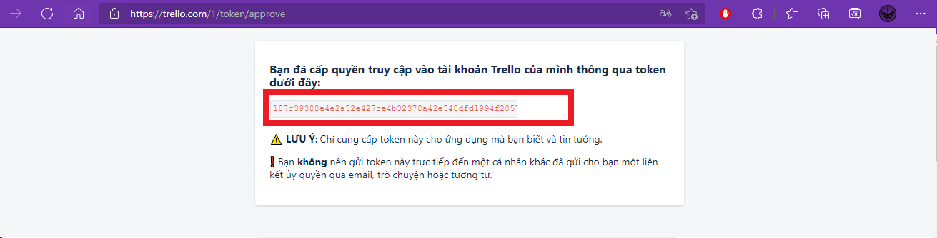

### Board ID

1. Go to your Trello Board
2. Board ID is the selection text in red area

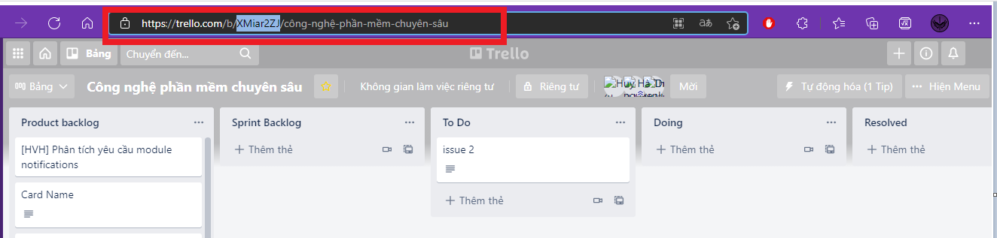

# Integration with Slack

## Require Information

### App Bot Token

#### What is App?

Apps connect other software you use (like Google Calendar, Salesforce, or one of your company's internal tools) to Slack. With all your tools in one place, you can streamline work and help people in your workspace collaborate more effectively.

#### What is Bot User?

Some Slack apps have [bot users](https://api.slack.com/bot-users#bots-overview) that can send messages and post in channels. You might receive a direct message (DM) from an app’s bot user (for example, with a link to fill out a survey created with the app) or see messages in channels posted by an app.

#### What is App Bot Token?

Bot tokens represent a bot associated with the app installed in a workspace. Unlike user tokens, they're not tied to a user's identity; they're just tied to your app.

Since acting independently allows your app to stay installed even when an installing user is deactivated, using bot tokens is usually for the best.

Check out the [guide to creating Slack apps with bot tokens](https://api.slack.com/authentication/basics) for more info.

Bot token strings begin with xoxb-

New bot users can request individual scopes, similar to user tokens.

### Chanel ID

Slack organizes conversations into dedicated spaces called channels. Channels bring order and clarity to work — you can create them for any project, topic, or team. With the right people and information in one place, teams can share ideas, make decisions, and move work forward.

## How to get them

### App Bot Token

1. Visit this Page and Login(If yet) : [Slack API: Applications | Slack](https://api.slack.com/apps)
2. Click “From Scratch”

1. Inform Name and Select Workspace

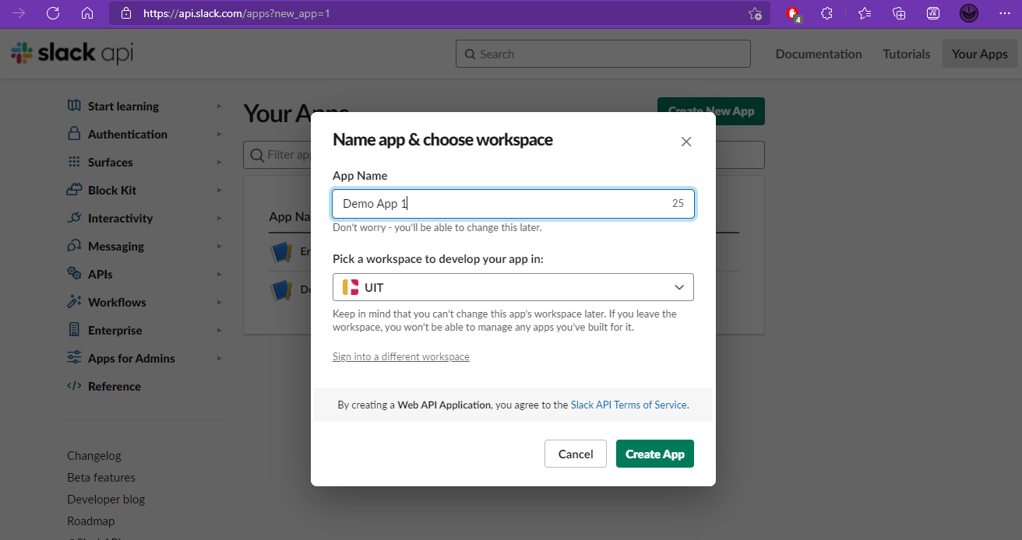

1. Select “Permissions”

1. Scroll to Scope Area and select permissions you want to add to your App

1. Sroll up and click “Install to WorkSpace”

1. Choose channel and “Allow”

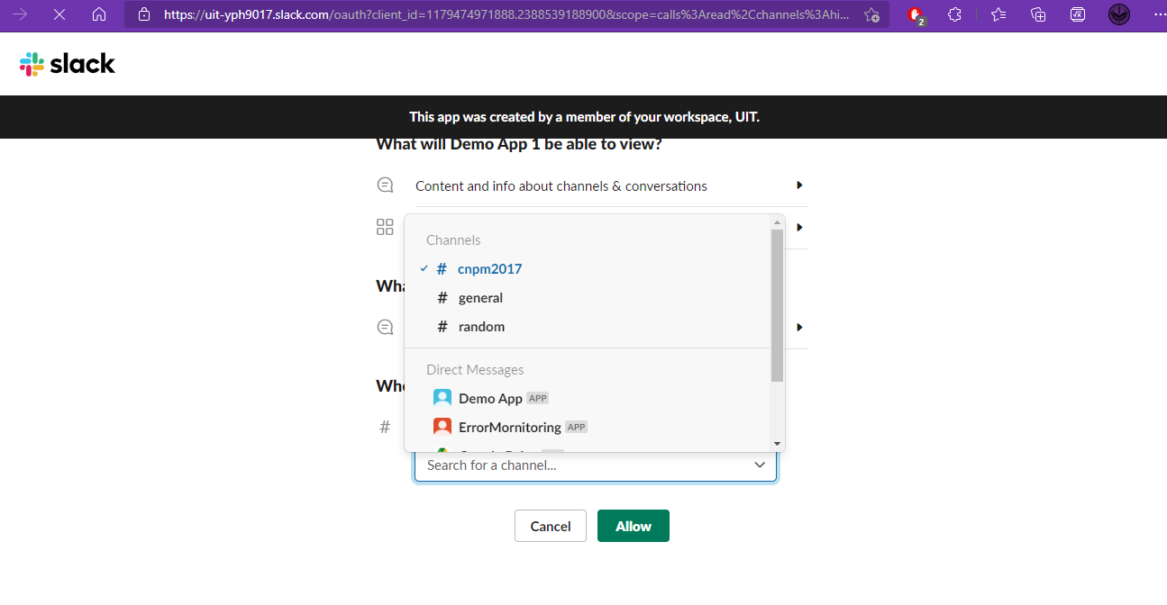

1. Copy your App Bot Token in red area

### Channel ID

1. Launch your Channel
2. The channel ID is the selection in red area

